## Group Names:

## 1873829 – Hafiz Muhammad Hassan

## 1871077 – Shahzad Amin

**HW3 Part B – Doodle Summary:**

**2. With this model at hand, initialize and then run 3 chains + a reasonable burn-in, to make inference on µ and σ. Report the relevant point estimates and credible intervals, qualitatively commenting on the mixing of the chain(s) by looking at the trace plots + autocorrelations (if you want, you can go deeper. . . )**

At first I have created required doodle model as shown in the below picture.

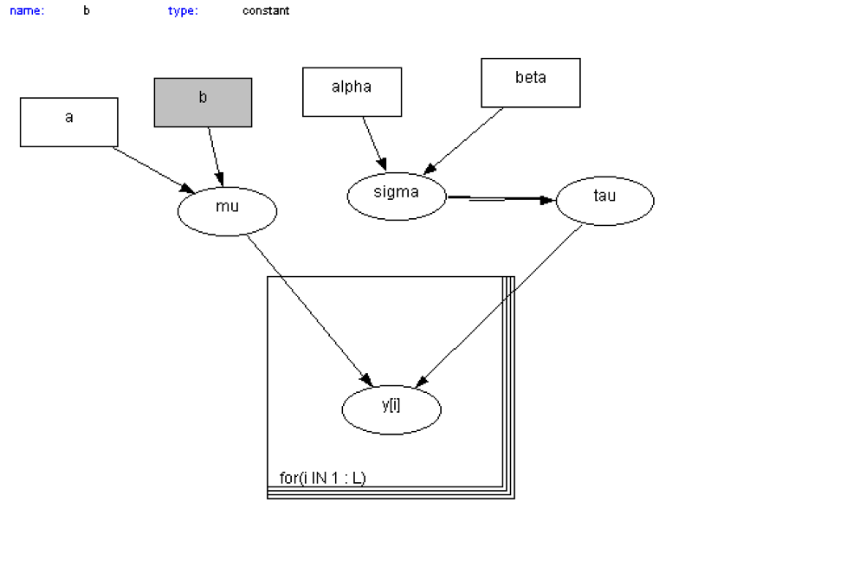

With this model at hand, I have initialized and then run 3 chains and burn in of 5000 to start sampling. Initial values and data values are given in required text file let me post a snapshot.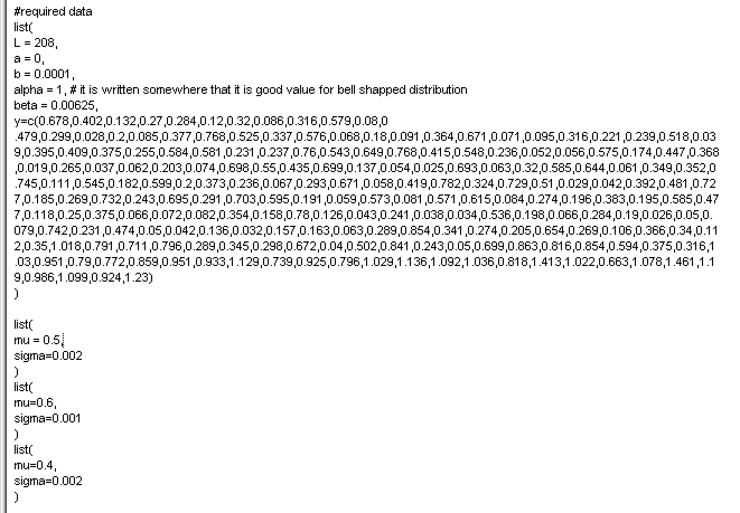

After that I have used sample monitor tool for monitoring the **mu** and **sigma** values. After actually running the model I have got these values for **mu** and **sigma**.

Here are the different chains values I will post the pictures here. These are the **point estimates.**



To get the different credible intervals values we can select it from the **OpenBugs** using sample monitor tools window. Here you can see it as **val2.5pc**, **median**, **val97.5c**.





After that I have mixed chains e.g 2 to 3, 1 to 2 but it always gave me same values for **mu** and **sigma** as given above for **mean**, **sd** etc.

After that I have looked at both densities as well.

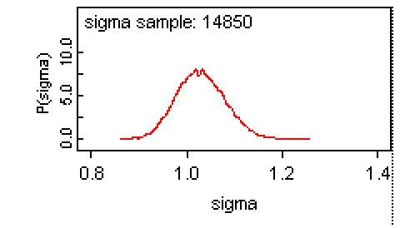

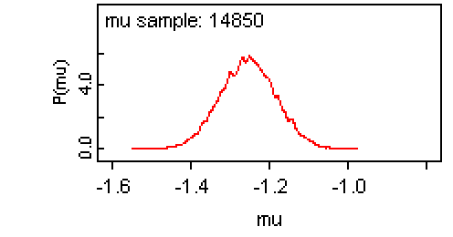

After that I have looked at their traces. Let me post graphs here.

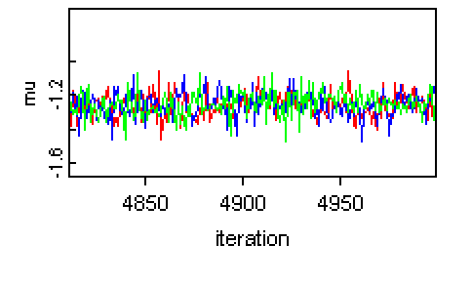

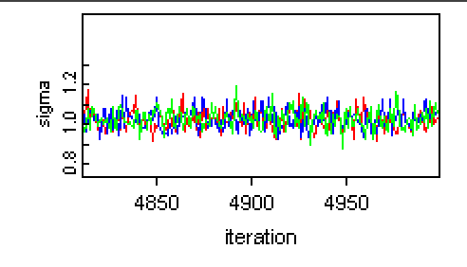

Now lets look at autocorrelations of both.

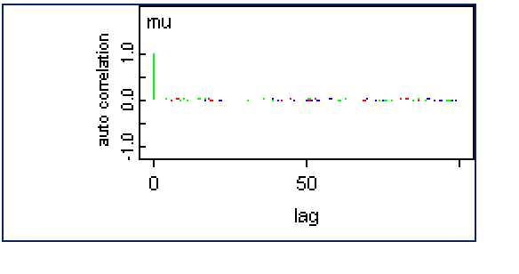

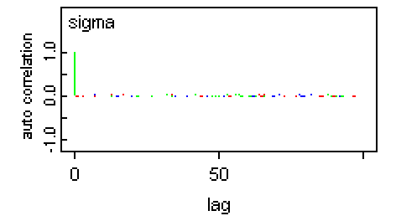

I have displayed all the things requested in Part B part 3. There is so much we can do with OpenBugs that I can’t even display here. Particularly we can use the logs window of the WinBugs to get this whole documentation procedure directly from Open Bugs.

**How to enable logs:**

<https://www.youtube.com/watch?v=ZwLpOzc5k7c>

Everything that we need in documentation are written here:

<http://homepage.stat.uiowa.edu/~gwoodwor/BBIText/AppendixBWinbugs.pdf>